NYSSLS Daily Lesson Plan
Instructional Unit: Weather and Climate |  |  |  |  | Period(s) of Unit: 2 |  |  | Date:
Materials/Resources/Links: Kite surfing I was lucky to Kite Surf this rare spot on Maui! (youtube.com)  convection tea bag experiment - Google Search |  |  |  |  |  |  |  | Course:  Earth Science
Special Notes for Lesson: Phenomena…Sea breeze vs land breeze “ Weather and Climate
Standards: HS-ESS2-8-Movementm and Interactions of Air Masses
HS-ESS2-2-Use Data to Claim that one change to Earths surface can create feedbacks causes change to Earths sys.
HS-ESS2-4 Use a model to describe variations in the flow of energy into and out of Earths Systems resulting in climates.

Science and Engineering Practices |  |  | Disciplinary Core Idea(s) |  |  |  | Cross Cutting Concepts
Performance Level
NYS Level 5 | NYS Level 4 |  |  | NYS Level 3 |  | NYS Level 2 |  | NYS Level 1
Collect and analyze global and regional weather data using tools, technologies, and/or models, to communicate in multiple formats how the movement and interactions of air masses result in changes in weather conditions. | Evaluate data and communicate information to explain how the movement and interactions of air masses result in changes in weather conditions. |  |  | Evaluate data and communicate information to identify the patterns of movement and/or interactions of air masses and/or the resulting changes in weather conditions. |  | Use data to identify the patterns of movement or the interactions of air masses and the resulting changes in weather conditions or to identify factors that drive the movement of air masses or from given weather conditions, identify evidence from maps that supports these conditions. |  | Use data and/or patterns of movement and interactions of air masses to identify the resulting changes in weather conditions or identify one factor that drives the movement of air masses or from those provided, use evidence from maps to account for weather conditions or given weather conditions, identify evidence found on maps that account for one of these conditions.
Clarification Statement –  This lesson would come into play after Astronomy and understanding how the angle of insolation plays a major concept of climate on earth as the Earth being Round plays on Temperate vs Tropical Zones. |  |  |  |  |  | Assessment Boundary  Analysis of understanding is the ability of the student to be able to draw a convection current to see How High pressure and low Pressure systems interact.
Connection to Anchoring Phenomenon: How Pressure systems are created by the ability of the earth to absorb energy by states of matter, texture, and color… How the sun’s angle increases or decreases this ability by the angle of insolation with its rotation and revolution.
Essential Question(s): Why do so many beach goers always condense at the waters edge and why are the beach volley ball nets always by the dunes or farthest away from the shore break or ocean.
Instructional Strategies & Learning Tasks: Engage, Explore, Explain, Elaborate, Evaluate
Engage: Anchoring phenomenon, demonstration; observations of images, video clip or data… |  | Little past learning of conduction, convection and radiation is important, to make sure all students understand that energy transfer is constantly occurring at the surface of the earth. The Kite phenomenon given as a link is going to get the students excited to figure of that there must be wind that is produced. But how is that sea breeze created so that the kite surfer can manipulate the sail to skip across the water at east, also what happens to the kite surfer’s ability as the sun is setting over time. Predict what happens to his ability to maneuver as wind shift occurs.
Explore: Students investigate, experiment, hands-on activity…. |  | First, I would go old school with a beaker and paper dots and explain how the kinetic energy is molecules are going from a condense state to expansion state and how energy is being inputted, just like the sun as it rises and becomes more direct. Once dots are moving in convection cells, have students draw on a worksheet the circular pattern. One could bring in potential energy and kinetic energy, less dense, more dense, warm= less dense vs cold=more dense. Now the kite phenomena are working on gas not water so a hands-on activity like students lighting tea bags to show convection currents rising would be a great activity for them to see hands on what is occurring at the beach on the sand. Also, reradiation can also come into play with heat capacity and specific heats of substances. Once the students have the grasp that when heat is applied by a hot plate or a match that the air or water molecules are expanding that this is creating a low pressure, and everything is rising. The opposite is when it is cold condensing is occurring and is moving downwards.  When the tea bag demo or class activity is occurring, this becomes a great time to use your ESRT Page 19 to show how these currents occur in the troposphere of the earth and creates weather patterns.  If your district has gizmo, there is also an awesome exploration that they could also do in order to understand the convection current mechanics. It could also be used as a way to give homework or supplemental work.
Explain: Students share their observations and evidence to explain their understanding…possible whole group/class discussion… |  | Simple diagram like this can be used to see if the students understand the mechanics of the convection cell in the beaker with hole punch dots.    convection tea bag experiment - Google Search  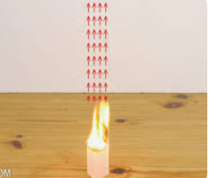  With the tea bag rocket, I would set up and organizer so that students would have to diagram the convection cell and then relate it to why there are fans on top of vaulted ceilings. What happens to the air when it increases in altitude. You can bring why the window of the plane is so cold?
Elaborate: Students apply the science concepts they’ve just learned… |  | So have the students stop the video of kite surfer in mauai when there is the beach and the water in play.  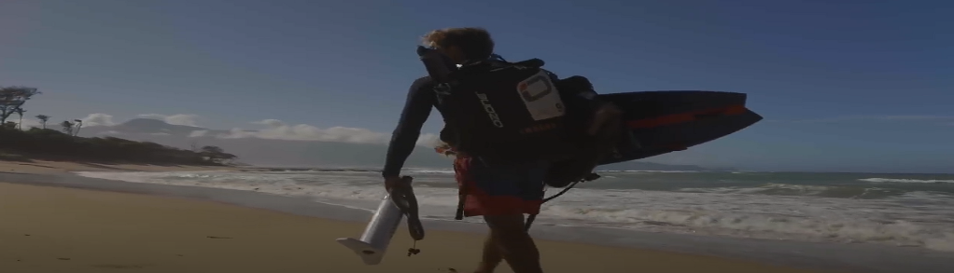
 |  | From the pic from the video the teacher through interactive lecture can draw the convection currents of the sea breeze with the water being the high pressure and land creating the low pressure. Could also bring a pic showing the beach and how everybody condenses at the water because that is the pressure gradient is the greatest and further back the volley ball nets would be in place because they is less a pressure gradient and less wind to affect the game.

Evaluate (Formative Assessment): Student learning is evaluated.

Evaluation or conclusion is to see if the student can explain how a land breeze would be created at night and shift the wind in the opposite direction explaining why it becomes very difficult towards the evening hours to kite surf because thay will be pushed out to sea and obivious a different skill set… The difference between novice and expert. To evaluate a conclusion I would give out a diagram with with the sun and then the moon to see how the convection currecnts reverse due to heat capacity or specific heats and how thermal conversion of convection currents allows for a movement of air by density difference.
As we write these next gen lessons….. I can see myself going into how the inner core heats up the earth and creates cpnvection currents in the mantle of the earth and creates divergence and convergence in different parts of the world.
Great opportunity to bring in pangea, orogeny, trenches and ridges.. Also brings in ESRT page 11,12

One aspect that can also be used is, How Kobe Bryant Died? Kobe’s helicopter went down in southern California because of a sea breeze that created a marine layer because of the plateau region. Great opportunity to teach weather and dewpoint with temperature and wind…

Copy and paste student worksheets below:
